CUNY SPS DATA 621 FInal Project
Predicting Credit Card Default
A Comparative Analysis of Parameter and Nonparametric
Classification Techniques
Valerie Briot, Michael D’acampora, Keith Folsom, Brian Kreis, Sharon Morris
5/25/2018

Applications of binary classification to predict credit card default using parametric and nonparametric methods

Table of Contents
Abstract 1
Keywords 1
Introduction 1
Literature Review 1
Methodology 3
Dataset Description 3
Performance Measurement 4
Experimentation and Results 5
Data Analysis and Transformation 5
Model Design 7
Conclusion 13
References 14
Appendix A - Detailed Exploratory Data Analysis: 15
Data Manipulation 20
Appendix B – R Code 21

Abstract
Financial institutions seek to minimize risk by identifying credit card holders who are likely to default on a payment. This research endeavors to explore and apply multiple classification techniques against the UCI credit card default dataset to determine which model provides the most predictive accuracy in identifying defaulters. We evaluate the following classifiers from both parametric and nonparametric models – binary logistic regression, Ridge and Lasso logistic regression, decision tree, and neural net. All models will be assessed against a specific performance metrics to select a single classifier with the best predictive power for credit card default prediction.

Keywords
Classification; UCI credit card dataset; Binary logistic; Regularized regression; Neural net

Introduction
Our project team has obtained a data set containing 30,000 observations with each observation representing a credit card customer. Variables included in the data set provide information on customer payment history, outstanding balances as well as demographic information. It is our task to develop a set of classification models to predict the probability that a customer will be in default of their next scheduled payment. The UCI credit card data set contains our default payment response variable, which is binary (0,1), an ID field, and 23 predictor variables. We will break the data set into a training and test set for our evaluation.
The objective is to build multiple classification models on the training data to predict the probability that a person will be in default of payment. We will then run analyses to determine which model performed best and apply subsampling techniques to attempt to further improve the model’s accuracy.
This model may be useful for financial institutions who provide revolving credit facilities to determine which customers may need intervention, including where reduction in the size of the outstanding credit facility would be prudent.
The paper is organized into the following sections:
- Literature Review reviews similar research published on the topic of financial risk management using data mining and classification to identify credit card default and the related field of fraud detection
- Methodology describes the approach and techniques used in this research
- Experimentation and Results provides an exploratory overview of the dataset and details the results of the models
- Discussion and Conclusions concludes research and identifies further areas of work

Literature Review
Credit card default prediction is described as an application of classification techniques within data mining. Financial and lending institutions employ probability of default (PD) models to calculate expected loss associated with default, and more generally identify individuals who are more likely to default on a payment. Similarly, fraud detection is another component within risk management employed to mitigate loss. Prediction of both credit card default and fraud see the application of similar binary classification algorithms. Due to the similarity between the two applications of classification, research dealing with both will be explored to more fully understand the current state and emerging state-of-the-art techniques. Also, the techniques highlighted address the challenges created by class imbalance in the outcome variable where the majority of cases (non-default or legitimate transactions) can significantly outnumber minority cases.
Universal to all literature in this area is the cited challenge with the lack of real-world data. Most available data is simulated or anonymized due to legal restrictions. Consequently, research development and the pool of available literature are somewhat limited or constrained by the limitations of the datasets. However, a key point is that the ability to apply accurate models within these risk management contexts can represent a huge potential savings for financial institutions.
Pasha, Fatima, Dogar, & Shahzad (2017) in their research explore the predictive accuracy of six algorithms for default prediction - linear discriminant analysis, Naïve Bayes, C4.5 decision tree, Logistic Regression, Neural Networks -MLP, and k-Nearest Neighbor (KNN). Their work evaluates performance using metrics such as accuracy, correct classification, incorrect classification, precision, and recall. The results show that the relatively newer algorithm of Multilayer Perceptron within the class of neural networks proves to be the best algorithm with an accuracy rate of 81.7%. It is worth noting that logistic regression is a close second in performance at 81%.
Altabrawee (2016) examines fourteen classification models and their predictive accuracy in default prediction. He notes the importance of a successful model’s ability to avoid underfitting or overfitting training data. In particular, the appropriate amount of regularization in the model should be used to limit under or overfitting. Performance results are evaluated in terms of average accuracy, precision, recall, and F score. The partial decision tree algorithm PART is determined to be the most accurate while Naïve Bayes-related algorithms are at the bottom in performance.
Butaru et al. (2015) research the application of machine learning techniques to the problem of credit risk. Their focus is on decision tree, random forest, and logistic regression models. Logistic regression models are noted to be the more traditionally used models for assessing credit risk. Regularization is used in their logistic regression model in order to be more in line with the anticipated performance of the decision trees and random forest models. Performance is evaluated using precision, recall, F score, and the kappa statistic. Their research determines that, although all three models performed well, decision trees and random forest outperform logistic regression especially within short time horizons.

Zareapoor and Shamsolmoali (2015) in their research also note that the lack of real world data for researchers has limited the amount of published literature available on the topic. Their premise is that ensemble learning techniques are superior to the other techniques tested. To assess model performance, Zareapooret et al. (2015) also use the metrics of Fraud Catching Rate, False Alarm Rate, Balanced Classification Rate, and Matthews correlation coefficient. They discount using accuracy and error rate, citing these as biased metrics. Their analysis shows that a bagged ensemble classifier using decision trees outperforms KNN, NB, and SVM.
Sahin and Duman (2011) focus on Neural Networks and Logistic Regression (binomial and multinomial) classification models. They too raise the challenge created by class imbalance and recommend the use of under and oversampling techniques. Specifically, Sahin and Duman (2011) employ a stratified sampling “to under sample the normal records so that the models have chance to learn the characteristics of both the normal and the fraudulent records’ profile” (p. 5). Their research shows a clear performance advantage of Neural Net models over LR models and cites the overfitting behavior of logistic regression. Among the logistic regression models, stepwise MLR is the champion in both accuracy performance and catching fraudulent transactions except the last case.
The review above of available research shows many relevant models, techniques, and insights useful for our own research. While parametric regression modeling is our main focus, we feel it important to consider techniques beyond logistic regression to more fully understand strengths and limitations of traditional techniques within the context of emerging state-of-the-art techniques. Clearly seen in the research though is that higher predictive accuracy is being driven through the use of ensemble machine learning techniques. While important to understand, ensemble techniques are outside the scope of this research.

Methodology
This research will explore several classification techniques against the UCI credit card default dataset to determine which model provides the most predictive accuracy in identifying payment default. Our work includes analyses using logistic regression models as this has traditionally been a common technique applied to default detection. However, we also apply more current approaches to better understand logistic regression within the context of emerging state-of-the-art machine learning classifiers.

Dataset Description
The UCI default credit card clients dataset consists of monthly payment data of credit cardholders of an undisclosed bank in Taiwan starting in September of 2005 and ending in April 2005. The data contains one binary response variable which indicates whether a payment default will occur in the next month. There are 23 explanatory variables included in the dataset. The dataset contains 30,000 total observations, of which 6,636 observations (28%) are for cardholders with a payment default indicator.
Table 1 Credit Card Default Dataset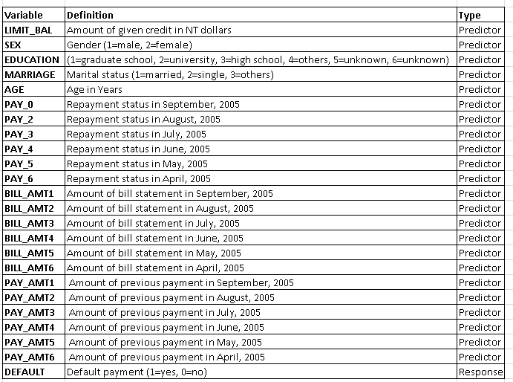
Exploratory data analysis is performed on the dataset using of descriptive analysis, correlation analysis, visualization, and Principle Component Analysis. The EDA phase is important in understanding the characteristics of the data for model building. Characteristics such as zero/missing values, skew, outliers, and potential data issues all inform the subsequent variable recoding and transformation applied to the data. Correlation and Principal Component Analysis (PCA) are used to identify existing collinearity among the predictor variables, notably the BILL_AMT variables. This is further confirmed through variance inflation factor (VIF) analysis.

Models Explored
- Binary Logistic Regression
- Logistic Regression using Ridge and Lasso Regularization
- Decision Trees
- Neural Net
We implement model fitting and testing using a 70% split of the transformed credit card default dataset. Both the training and test datasets are created through random sampling. The training dataset is used to fit all models evaluated in this research and, similarly, the test dataset is used to determine predictive performance of the same models based on a hold-out dataset.

Performance Measurement
A critical feature of the credit card default prediction models being evaluated is their ability to accurately predict whether a cardholder will default on next month’s payment. As such, accuracy will be one measure used to determine a model's performance. However, accuracy alone does not provide a full picture for model assessment, so the following performance measures will be used:
F1-score
The harmonic mean of the precision and recall
Kappa statistic
Kappa takes into account the accuracy that would be generated purely by chance. Kappa takes on values from -1 to +1, with a value of 0 meaning there is no agreement between the actual and classified classes. A value of 1 indicates perfect concordance of the model prediction and the actual classes and a value of 0 indicates total disagreement between prediction and the actual.
Sensitivity
Sometimes called the true positive rate, sensitivity is rate of that the event of interest, in this case default, is correctly predicted within the sample (Kuhn et al. 2013).
Specificity
As the converse of sensitivity, specificity is true negative rate and is the rate at which the nonevent is correctly identified as the nonevent within the sample (Kuhn et al. 2013)
Balanced Accuracy
Defined as (Sensitivity + Specificity)/2, balanced accuracy provides a potentially more accurate metric of accuracy in binary classification models with potentially imbalanced class distributions.
False-Positive Rate
Sometimes called the false alarm rate, false-positive rate is defined as 1 - Specificity.
Youden's Index
Youden’s index evaluates the ability of a classifier to avoid misclassifications. This index puts equal weights on a classifier’s performance on both the positive and negative cases.
Model selection is performed using the performance metrics noted above as the selection criteria. Each model's performance will be assessed using the same test dataset.

Experimentation and Results

Data Analysis and Transformation
We performed a detailed exploratory data analysis to understand the characteristics of the data and the relationship between the variables. There were no missing data and as such no imputation was necessary. We did have to handle unknown and zero-values. This lead us to recoding a number of variables into dummy variables.
Most of the customers are females and went to university. A larger number of customers are single, and the proportion of default payments appears to be higher for married individuals. The AGE distribution is right-skewed and would indicate that younger customers tend to default at a higher rate. A majority of customers are making payments on time or ahead of schedule. The number of extremely late payments in the latter months is more infrequent. We can presume that this list only contains customers whose accounts have not yet been charged off, for which we would expect no future payments. Customers with extremely late repayment statuses 6 months ago have likely already been charged off. It is somewhat surprising that PAY_0, PAY_2 and PAY_3 contain lower frequencies of extremely late payment statuses. The majority of payments are of small values with some rather large outliers. As we would expect, the majority of customers are not in default on their next payment.
Correlation Analysis
As shown below there is high collinearity among variables where we would expect it to occur. For instance in Bill Amount, for which we have six variables all corresponding to different months, we would expect a relation between the amount someone owes one month and the amount that they owe the next. This is also true of the Payment Amount variable, for which we also have 6 sequential months of data for.
As we would expect, the DEFAULT variable is most strongly correlated with the payment status. If a person were to default in one payment period, intuitively we would think that may have a relationship with other periods.
The tables below represent correlation between response and predictor variables.
Fig. 1 Correlation among predictor variables
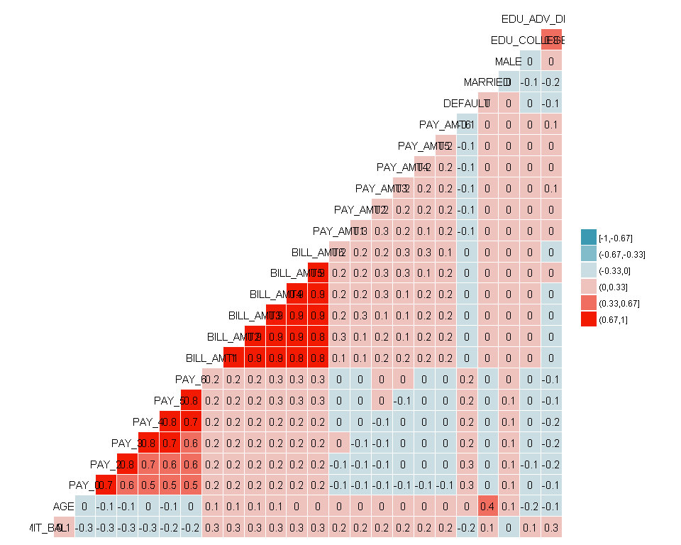
PCA component analysis
As mentioned earlier we have quite a bit of collinearity among predictors, as demonstrated by the scree plot below; the variability accounted for by each component drops sharply within the first few components.
Fig. 2 PCA scree plot
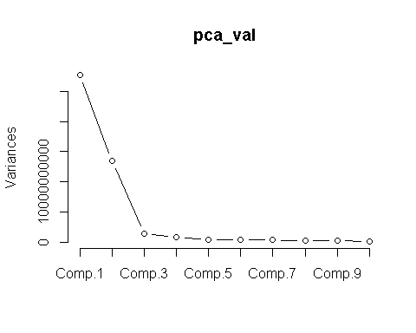
Data Manipulation
The variables MARRIAGE, SEX and EDUCATION were all converted to dummy variables. As discussed previously, we combined values 4, 5 and 6 in education to create an all-encompassing other category. We will also change the unknown value of 0 in MARRIAGE to 3(other).
We have very high variance inflation factor (VIF) values for all of the BILL_AMT variables. VIF values indicate the severity of collinearity among variables. This is not all that surprising as we would not expect the bills to change significantly from month to month for an individual in general. We created additional variables in attempt to account for the variation that these variables represent and remove the original variables. The following variables were created:
- AVG_BILL: The average bill over the six-month period for each customer
- AVG_BILL_TO_LIMIT: The AVG_BILL variable divided by that individual customer’s credit limit
- PAY_TO_BILL: Average Payment made over the 6 months divided by the AVG_BILL
- INC_COUNT: It may also be worthwhile to see for how many months the customer’s bill increased from one month to the next. This shows how often a customer is spending more than they payoff each month. If this occurs for five consecutive months, it may indicate a worsening financial condition.

Model Design
In this section, we compare the four default prediction models – binary logistic regression, regularized logistic regression, decision tree, and Neural Networks. Each model is fit against the same training dataset as described in the methodology.

Binary Logistic Regression
We use binary logistic regression from among the family generalized linear models as the baseline model for this research. Stepwise variable selection using both the forward and backward options is used to obtain the optimal model based on the lowest AIC (Akaike Information Criterion)
Fig. 3 Variable importance among predictors
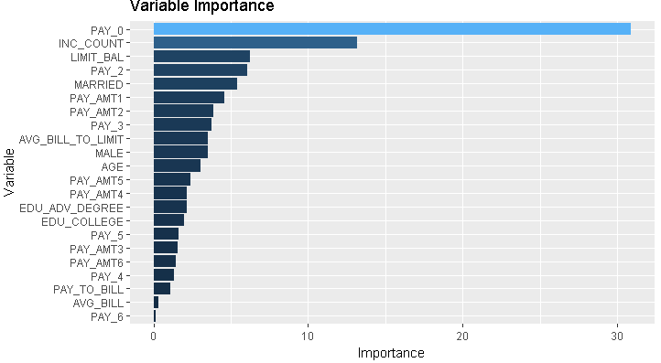

Ridge and Lasso Regularization
Regularization is applied using the same parameters established in the binary logistic regression model but attempts to minimize the impact of the coefficients. Both Ridge and Lasso approaches attempt to reduce overfitting by applying a penalty to the parameter estimates. This is a tunable parameter known as λ.
Ridge regression applies standardization to the predictor variables and uses L2 Regularization by applying a penalty term where the parameter estimates are only allowed to increase if there is a proportional decrease in the sum of squared errors (Kuhn et al 2013). Ridge regression has benefits when multicollinearity exists among the predictors and overall seeks to reduce model complexity.
Lasso, or least absolute shrinkage and selection operator, is similar to Ridge and applies a similar penalty but uses L1 regularization. Lasso has the added benefit of feature selection which ridge does not.
Fig. 4 Ridge – Optimal lambda value Fig. 5 Lasso– Optimal lambda value
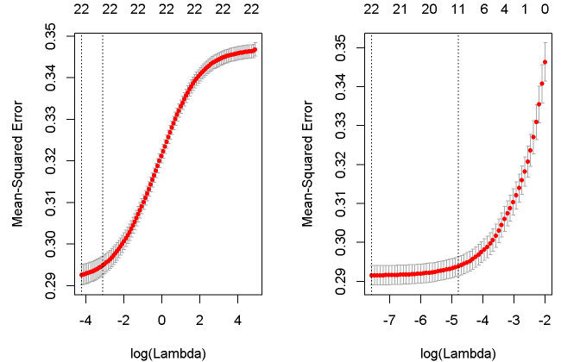
Table 2 Coefficient comparison between Ridge and Lasso models:
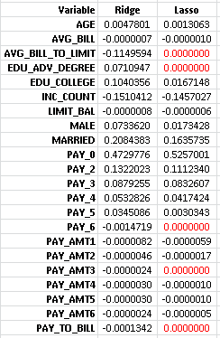
We see that the feature selection of Lasso removed PAY_6, PAY_AMT3, EDU_ADV_DEGREE, AVG_BILL_TO_LIMIT, and PAY_TO_BILL (highlighted in red above) as predictors in the model.

Decision Tree
A basic decision tree was used on this data set to predict default, and it partitions the data into smaller groups that are more homogeneous with respect to the response. It is a type of supervised learning algorithm that is mostly used in classification problems, however it works for categorical and continuous variables.
The figure below shows a representation to the cross validated error summary. The cp values are plotted against the geometric mean until a minimum value is reached. It is a method to help determine if a tree should be pruned, and in our case, pruning is not necessary since the model chose the minimal amount of leaf nodes necessary to construct a decision tree. Had there been more leaf nodes we would choose the lowest point on the graph and prune all nodes to the right of it.
Fig. 6 Cross Validated Error Summary plot
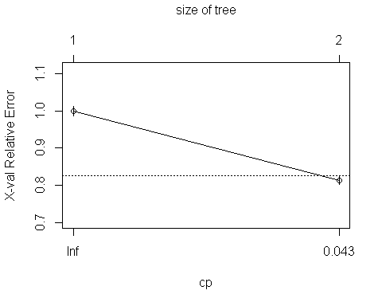
The summary shows the root node splits the 20998 observations into groups of 18789 and 2209 (nodes 2 and 3) with mean values of 0.167 and 0.698, respectively. Variables PAY_0 is weighted by far highest in importance, with PAY_5 and PAY_4 a distant second.
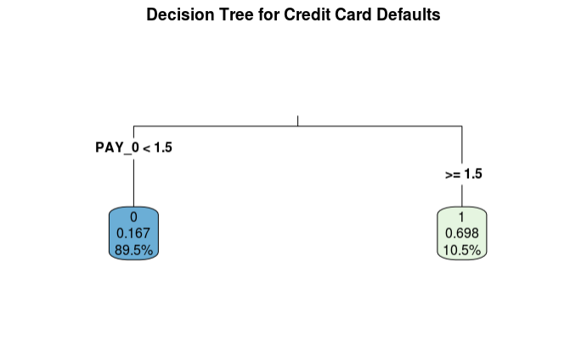
Fig. 7 Decision Tree Graph
Lastly in the plotting section is a visual of the regression tree. The model tells us that if PAY_0 >=1.5, there is a 69.8% chance the customer will default. Approximately 10.5% of the data set falls under this threshold. On the other hand, if PAY_0 < 1.5, there is a 16.7% likelihood the customer will default, which 89.5% of the data set falls under.

Neural Network
Neural network was chosen to predict default because of its ability to adjust weights and connections of the inputs and outputs of the model. The twenty-three predictors used to predict default were the original inputs to the model and were weighted to determine the values of each or the predictors. There are 2 hidden units in the third layer and 4 hidden units in the second layer. The network was tested in the testing set.
As neural networks use activation functions between -1 and +1 - the variables were scaled down. This is done to prevent the neural network from spend training iterations doing the scaling. Min-max normalization was used to transform the data into a common range. This removes the scaling effect from all the variables.

The neural network plot represents the weights of each connection. The visualization shows the 3 hidden layers. The black lines of the model represent the connections with weights. The weights are calculated using the back-propagation algorithm. The blue line displays the bias terms. The training process required 2355,00000 steps until all absolute partial derivatives of the error function were smaller than 0.01, which is the default threshold. The estimated weights ranged between -120.19 and 23.24 Neural Network Matrix
Fig. 8 Neurol Network Plot

Models Comparison
The five models were each tested against a test or hold-out set of data containing 9,000 observations from the credit card default dataset. The following performance metrics are captured for evaluation: (1) Accuracy, (2) F1-Score, (3) Kappa, (4) Sensitivity, (5)Specificity, (6) Balanced Accuracy = (Sensitivity + Specificity)/2, (6) False-Positive Rate = (1 – Specificity), and (7) Youden’s J Index.
The confusion matrices for the five models against the test dataset with prediction results are shown below.

Fig. 9 Confusion Matrices for the five models using the test dataset
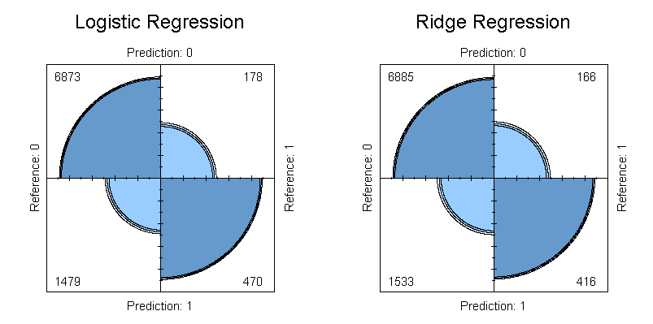
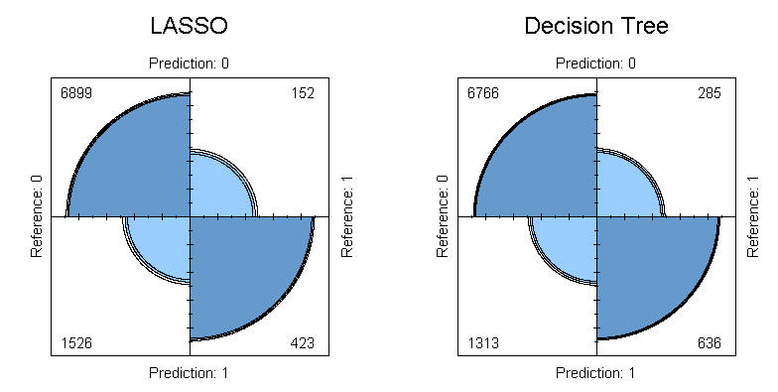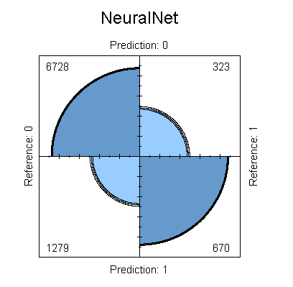

Table 3 shows the consolidated performance metrics of the five models. Initial review shows that the parametric regression models – baseline logistic regression, Ridge, and Lasso – all have accuracy rates less than those of the decision trees and Neural Net models.
The performance of the three parametric models is fairly equivalent, looking across accuracy, F1-score, and sensitivity and specificity. Sensitivity, which indicates the model’s ability to predict default, ranges from 71.5% to 74% which fairly good. Specificity for these models ranges from 81% to 82% which is better than the no-information rate of 78% if one predicted a non-default value for each observation in the test set.
It is interesting to note that the Lasso model has the highest balanced accuracy among all models at 78%.
The non-parametric decision tree and neural net models outperform the parametric models in accuracy, F1-score, and Kappa. Their balanced accuracy is roughly on par with those of the logistic regression and ridge models. The non-parametric models do differ in sensitivity and specificity. These models seem slightly less sensitive to predicting defaults while showing a higher specificity for non-default predictions.
Table. 3 Model Performance Metrics
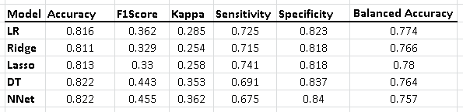
Another consideration which should be factored into the final model selection is the false-positive rate. A bank looking to implement a default prediction model would likely seek to minimize the number of false alarms generated by the algorithm. The Neural Net model has the lowest false-positive rate as well as the lowest Youden’s Index.
Table 4 Model Performance Metrics Continued
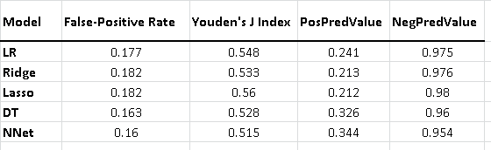
The decision tree and Neural Net models are very comparable in performance across all metrics. Therefore, the lower false alarm rate of the Neural Net model makes this the selected model.

Conclusion
We were able to predict with some measure of accuracy the occurrence of credit card default in our selected dataset. After comparing parametric and nonparametric models, we determined that the nonparametric Neural Network model outperformed the other models. The decision tree model came in close second in predictive performance after Neural Networks. One of the key factors in the decision to select the Neural Network model over the Decision Tree model was the lower false alarm rate of the Neural Network model. A natural next step would be to apply this model to a wider population and evaluate how well it performs. We have some concerns on the matter for two reasons: (1) the data set we used in our analysis may not be representative of a larger population, the majority of the customers had higher education and appeared to be younger than a general population, and (2) the binary response variable (default/non-default) may introduce class imbalance with an approximate ratio (28/72). This may warrant the exploration of alternate sampling approaches as a future consideration. Another line of inquiry would be to evaluate and predict the time to default by building a survival model. The limited number of period in our data set (6 months) did not lend itself to this analysis.

References
Altabrawee, H. (2016). Performance Evaluation of Fourteen Machine Learning Algorithms on Credit Card Default Classification. Education College Journal, 463-473
Butaru, F., Chen, Q., Clark, B., Das, S., Lo, A., & Siddique, A. (2015). Risk and Risk Management in the Credit Card Industry. doi:10.3386/w21305
Koklu, M., & Sabanci, K. (2016). Estimation of Credit Card Customers Payment Status by Using kNN and MLP. International Journal of Intelligent Systems and Applications in Engineering, 249-251
Kuhn, M., & Johnson, K. (2013). Applied predictive modeling. New York: Springer.
Lusis. (2017, April 20). A Comparison of Machine Learning Techniques for Credit Card Fraud Detection. Retrieved from http://www.lusispayments.com/uploads/4/4/8/2/44826195/a_comparison_of_machine_learning_techniques_for_credit_card_fraud_detection.pdf
Padmaja, T. M., Dhulipalla, N., Krishna, P. R., Bapi, R. S., & Laha, A. (2007). An Unbalanced Data Classification Model Using Hybrid Sampling Technique for Fraud Detection. Lecture Notes in Computer Science, 341-348. doi:10.1007/978-3-540-77046-6_43
Pasha, M., Fatima, M., Dogar, A. M., & Shahzad, F. (2017, March). Performance Comparison of Data Mining Algorithms for the Predictive Accuracy of Credit Card Defaulters. Retrieved from http://paper.ijcsns.org
Sahin, Yusuf &Duman, Ekrem. (2011). Detecting credit card fraud by ANN and logistic regression. INISTA 2011 - 2011 International Symposium on INnovations in Intelligent SysTems and Applications. 10.1109/INISTA.2011.5946108.
Seeja, K. R., & Zareapoor, M. (2014). FraudMiner: A Novel Credit Card Fraud Detection Model Based on Frequent Itemset Mining. The Scientific World Journal, 2014, 252797. http://doi.org/10.1155/2014/252797
Zareapoor, M., & Shamsolmoali, P. (2015). Application of Credit Card Fraud Detection: Based on Bagging Ensemble Classifier. Procedia Computer Science, 48, 679-685. doi:10.1016/j.procs.2015.04.201
https://datascienceplus.com/fitting-neural-network-in-r/ https://www.youtube.com/watch?v=LTg-qP9iGFY https://www.analyticsvidhya.com/blog/2017/09/creating-visualizing-neural-network-in-r/
https://stats.stackexchange.com/questions/21717/how-to-train-and-validate-a-neural-network-model-in-r http://blog.revolutionanalytics.com/2016/03/com_class_eval_metrics_r.html

Appendix A - Detailed Exploratory Data Analysis:
Missing and Zero Values
The data does not contain missing values and as such no imputation will be necessary.
Descriptive Statistics
Descriptive statistics was performed for all predictor and response variables to explore the data.
Analysis of Variables
##
## -2 -1 0 1 2 3 4 5 6 7 8
## 2759 5686 14737 3688 2667 322 76 26 11 9 19
LIMIT_BAL
The majority of customers have lower credit limits, as such the distribution is right skewed
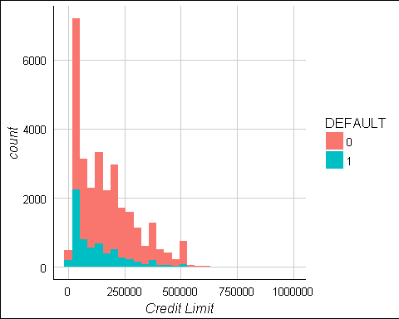
SEX
The majority of customers are female. This variable can be made into a dummy variable.
EDUCATION
The majority of customers went to university, there are very few in the other/unknown categories as well as an unknown 0 value and we will consider combining these values into dummy variables of College and Advanced Degree, with a 0 value in the College variable representing High School and all other possibilities.
MARRIAGE
The majority of customers are single and the proportion of default payments appears to be higher for married individual. It appears that there are 0 values here which were not planned. It may be prudent to instead code this as a binary married variable.
AGE
The distribution is right skewed. We can see that extremely young customers seem to have a higher proportion of defaults.
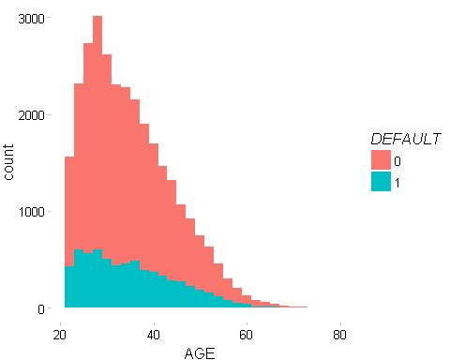

Repayment Status
The vast majority of clients are on time or ahead of payments. The number of extremely late payments in the latter months are more infrequent. We can presume that this list only contains customers whose accounts have not yet been charged off, for which we would expect no future payments. Customers with extremely late repayment statuses 6 months ago have likely already been charged off. It is somewhat surprising that PAY_0, PAY_2 and PAY_3 contain lower frequencies of extremely late payment statuses.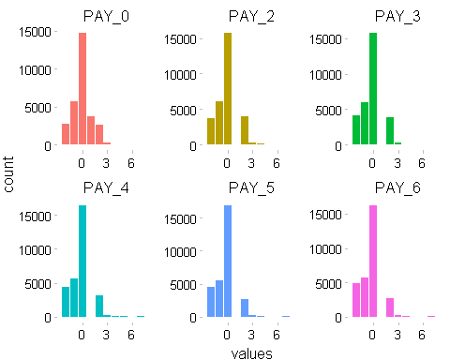

Bill Amount
We appear to have some negative values for bill amount. This likely represents overpayment by the customer and is not problematic. The distributions are similar.
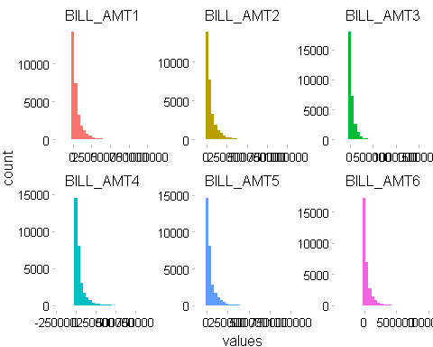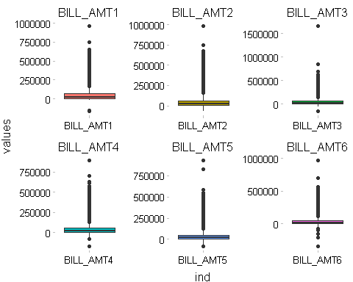

Pay Amount
The majority of payments are small with some rather large outliers.
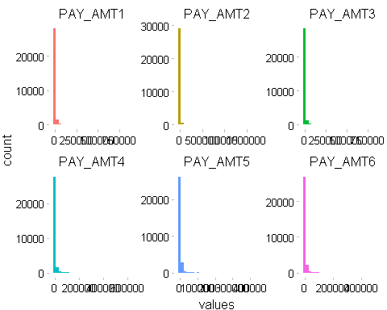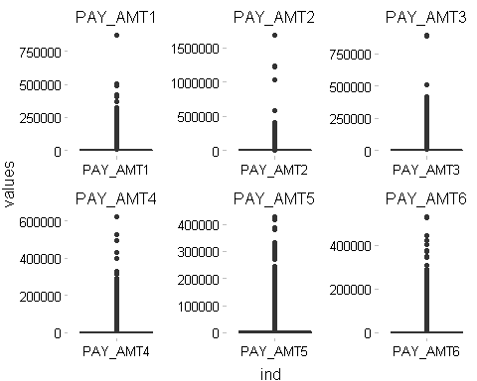

DEFAULT
As we would expect the majority of customers are not in default of their next payment. 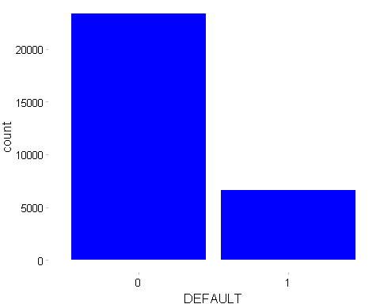

Data Manipulation
As discussed previously, we will combine values 4, 5 and 6 in education to create an all encompassing other category. We will also change the unknown value of 0 in MARRIAGE to 3(other)
Recode Predictors

Change values to factors
## LIMIT_BAL AGE PAY_0 PAY_2 PAY_3
## "numeric" "integer" "integer" "integer" "integer"
## PAY_4 PAY_5 PAY_6 BILL_AMT1 BILL_AMT2
## "integer" "integer" "integer" "numeric" "numeric"
## BILL_AMT3 BILL_AMT4 BILL_AMT5 BILL_AMT6 PAY_AMT1
## "numeric" "numeric" "numeric" "numeric" "numeric"
## PAY_AMT2 PAY_AMT3 PAY_AMT4 PAY_AMT5 PAY_AMT6
## "numeric" "numeric" "numeric" "numeric" "numeric"
## DEFAULT MARRIED MALE EDU_COLLEGE EDU_ADV_DEGREE
## "integer" "numeric" "numeric" "numeric" "numeric"

Appendix B – R Code
## ----libraries, echo=FALSE, message=FALSE, warning=FALSE-----------------
library(psych)
library(GGally)
library(ggplot2)
library(ggthemes)
library(reshape2)
#library(VIM)
# library(mice)
# library(stringr)
library(dplyr)
library(car)
library(usdm)
library(tidyverse)
library(stringr)
library(DataExplorer)
library(knitr)
# library(corrplot)
library(MASS)
library(Metrics)
# library(tinytex)
# library(ggfortify)
library(caret)
library(pscl)
library(MKmisc)
library(Metrics)
library(pROC)
library(rpart)
library(rpart.plot)
library(glmnet)
library(neuralnet)
# library(gvlma) ## only used for confirming model assumptions
options(scipen=999)
## ----Read data, echo=FALSE, message=FALSE, warning=FALSE-----------------
cc_data <- read.csv("https://raw.githubusercontent.com/621-Group2/Final-Project/master/UCI_Credit_Card.csv", header=TRUE, sep=",")
#Remove the id from the dataset
cc_data$ID <- NULL
#Simplify name of response
colnames(cc_data)[24] <- "DEFAULT"
## ----user_functions, echo=FALSE, message=FALSE, warning=FALSE------------
as.numeric.factor <- function(x) {as.numeric(levels(x))[x]}
# get_outliers function
get_outliers <- function(x, n = 10) {
bp <- boxplot.stats(x)
obs_hi <- unique(x[which(x > bp$stats[5])])
if (length(obs_hi) < n) { n <- length(obs_hi) }
hi <- sort(obs_hi, decreasing = T)[1:n]
obs_low <- unique(x[which(x < bp$stats[1])])
if (length(obs_low) < n) { n <- length(obs_low) }
low <- sort(obs_low, decreasing = T)[1:n]
return (list(Hi=hi, Low=low))
}
#Keith's function
all_model_metrics <- data.frame()
all_roc_curves <- list()
all_predictions <- list()
all_cm <- list()
calc_metrics <- function(model_name,
model,
test,
train) {
pred_model <- predict(model, test, type = 'response')
y_pred_model <- factor(ifelse(pred_model > 0.5, 1, 0), levels=c(0, 1))
compare <- cbind (actual=as.numeric.factor(test$target),
predicted=as.numeric.factor(y_pred_model)) # combine
# Confusion Matrix
cm <- confusionMatrix(test$target, y_pred_model, positive = "1", mode="everything" )
accuracy <- cm$overall[[1]]
kappa_value <- cm$overall[[2]]
youden_value <- cm$byClass[[1]] - (1 - cm$byClass[[2]])
F1Score_value <- cm$byClass[[7]]
FP_value <- (cm$table[2,1]/nrow(test))*100
#AUC
#AUC_value <- auc(as.numeric(test$target), pred_model)
cm_df <- data.frame(Model=model_name,
Accuracy=round(accuracy, 3),
AIC=round(AIC(model), 3),
BIC=round(BIC(model), 3),
MAE=Metrics::mae(compare[, 1], compare[, 2]),
MAPE=Metrics::mape(compare[, 1], compare[, 2]), #MAPE calculates the mean absolute percentage error:
MSE=Metrics::mse(compare[, 1], compare[, 2]), #MSE calculates mean squared error
RMSE=Metrics::rmse(compare[, 1], compare[, 2]),
Kappa = round(kappa_value, 3),
Youden = round(youden_value, 3),
F1Score = round(F1Score_value, 3),
FPPrct = round(FP_value, 2),
Sensitivity=round(cm$byClass["Sensitivity"], 3),
Specificity=round(cm$byClass["Specificity"], 3),
PosPredValue=round(cm$byClass["Pos Pred Value"], 3),
NegPredValue=round(cm$byClass["Neg Pred Value"], 3),
Precision=round(cm$byClass["Precision"], 3),
Recall=round(cm$byClass["Recall"], 3),
BalancedAccuracy=round(cm$byClass["Balanced Accuracy"], 3)
)
#cbind(t(cm$overall),t(cm$byClass)))
# ROC Curves
roc_model <- roc(target ~ pred_model, data = test)
# Result
result <- list(cm_df, roc_model, compare, cm)
return (result)
}
## this for used for the ridge and lasso regression models
calc_metrics_2 <- function(model_name,
model,
test,
train,
s,
y_test) {
pred_model <- predict(model, newx = test, s=s, type="response")
y_pred_model <- as.factor(ifelse(pred_model > 0.5, 1, 0))
compare <- cbind (actual=as.numeric.factor(y_test),
predicted=as.numeric.factor(y_pred_model)) # combine
# Confusion Matrix
cm <- confusionMatrix(as.factor(y_test), y_pred_model, positive = "1", mode="everything" )
accuracy <- cm$overall[[1]]
kappa_value <- cm$overall[[2]]
youden_value <- cm$byClass[[1]] - (1 - cm$byClass[[2]])
F1Score_value <- cm$byClass[[7]]
FP_value <- (cm$table[2,1]/nrow(test))*100
#AUC
#AUC_value <- auc(as.numeric(test$target), pred_model)
cm_df <- data.frame(Model=model_name,
Accuracy=round(accuracy, 3),
AIC=NA,
BIC=NA,
MAE=Metrics::mae(compare[, 1], compare[, 2]),
MAPE=Metrics::mape(compare[, 1], compare[, 2]), #MAPE calculates the mean absolute percentage error:
MSE=Metrics::mse(compare[, 1], compare[, 2]), #MSE calculates mean squared error
RMSE=Metrics::rmse(compare[, 1], compare[, 2]),
Kappa = round(kappa_value, 3),
Youden = round(youden_value, 3),
F1Score = round(F1Score_value, 3),
FPPrct = round(FP_value, 2),
Sensitivity=round(cm$byClass["Sensitivity"], 3),
Specificity=round(cm$byClass["Specificity"], 3),
PosPredValue=round(cm$byClass["Pos Pred Value"], 3),
NegPredValue=round(cm$byClass["Neg Pred Value"], 3),
Precision=round(cm$byClass["Precision"], 3),
Recall=round(cm$byClass["Recall"], 3),
BalancedAccuracy=round(cm$byClass["Balanced Accuracy"], 3)
)
#cbind(t(cm$overall),t(cm$byClass)))
# ROC Curves
roc_model <- roc(as.numeric(y_test) ~ as.numeric(pred_model), data = as.data.frame(test))
# Result
result <- list(cm_df, roc_model, compare, cm)
return (result)
}
## used for neuralnet and decision tree
calc_metrics_3 <- function(model_name,
model,
test,
train,
type=NULL,
y_test=NULL) {
if (type=="nnet") {
pred_model <- neuralnet::compute(model, test[, -23])$net.result
y_pred_model <- as.factor( ifelse(pred_model > 0.5, 1, 0) )
target <- y_test
}
else {
pred_model <- predict(model, test, type = "prob")[,"1"]
y_pred_model <- as.factor(ifelse(pred_model > 0.5, 1, 0))
target <- test$target
}
compare <- cbind (actual=as.numeric.factor(target),
predicted=as.numeric.factor(y_pred_model)) # combine
# Confusion Matrix
cm <- confusionMatrix(as.factor(target), y_pred_model, positive = "1", mode="everything" )
accuracy <- cm$overall[[1]]
kappa_value <- cm$overall[[2]]
youden_value <- cm$byClass[[1]] - (1 - cm$byClass[[2]])
F1Score_value <- cm$byClass[[7]]
FP_value <- (cm$table[2,1]/nrow(test))*100
#AUC
#AUC_value <- auc(as.numeric(test$target), pred_model)
cm_df <- data.frame(Model=model_name,
Accuracy=round(accuracy, 3),
AIC=NA,
BIC=NA,
MAE=Metrics::mae(compare[, 1], compare[, 2]),
MAPE=Metrics::mape(compare[, 1], compare[, 2]), #MAPE calculates the mean absolute percentage error:
MSE=Metrics::mse(compare[, 1], compare[, 2]), #MSE calculates mean squared error
RMSE=Metrics::rmse(compare[, 1], compare[, 2]),
Kappa = round(kappa_value, 3),
Youden = round(youden_value, 3),
F1Score = round(F1Score_value, 3),
FPPrct = round(FP_value, 2),
Sensitivity=round(cm$byClass["Sensitivity"], 3),
Specificity=round(cm$byClass["Specificity"], 3),
PosPredValue=round(cm$byClass["Pos Pred Value"], 3),
NegPredValue=round(cm$byClass["Neg Pred Value"], 3),
Precision=round(cm$byClass["Precision"], 3),
Recall=round(cm$byClass["Recall"], 3),
BalancedAccuracy=round(cm$byClass["Balanced Accuracy"], 3)
)
#cbind(t(cm$overall),t(cm$byClass)))
# ROC Curves
roc_model <- roc(as.numeric(target) ~ as.numeric(pred_model), data = as.data.frame(test))
# Result
result <- list(cm_df, roc_model, compare, cm)
return (result)
}
plot_varImp <- function(model) {
x <- data.frame(varImp(model))
x$Variable <- rownames(x)
x %>% ggplot(aes(x=reorder(Variable, Overall), y=Overall, fill=Overall)) +
geom_bar(stat="identity") + coord_flip() + guides(fill=FALSE) +
xlab("Variable") + ylab("Importance") +
ggtitle("Variable Importance")
}
## ----data exploration, echo=FALSE, message=FALSE, warning=FALSE----------
Variable <- colnames(cc_data)
Definition <- c("Amount of given credit in NT dollars", "Gender (1=male, 2=female)", "(1=graduate school, 2=university, 3=high school, 4=others, 5=unknown, 6=unknown)", "Marital status (1=married, 2=single, 3=others)", "Age in Years", "Repayment status in September, 2005", "Repayment status in August, 2005", "Repayment status in July, 2005", "Repayment status in June, 2005", "Repayment status in May, 2005", "Repayment status in April, 2005", "Amount of bill statement in September, 2005", "Amount of bill statement in August, 2005", "Amount of bill statement in July, 2005", "Amount of bill statement in June, 2005", "Amount of bill statement in May, 2005", "Amount of bill statement in April, 2005", " Amount of previous payment in September, 2005", " Amount of previous payment in August, 2005", " Amount of previous payment in July, 2005", " Amount of previous payment in June, 2005", " Amount of previous payment in May, 2005", " Amount of previous payment in April, 2005", "Default payment (1=yes, 0=no)")
card_sum <- cbind.data.frame (Variable, Definition)
card_sum$Type <- "Predictor"
card_sum[24,3] <- "Response"
write.csv(card_sum, 'dataset_description.csv', row.names = F)
knitr::kable(card_sum, caption="Table 1. Credit Card Default Dataset")
## ----miss_plot, echo=FALSE, message=FALSE, warning=FALSE, eval = FALSE----
##
## plot_missing(cc_data, title="Credit Card Data - Missing Values (%)")
##
## ----descriptive statistics, echo=FALSE, message=FALSE, warning=FALSE, eval = FALSE----
##
## #Use Describe Package to calculate Descriptive Statistic
## (CC_des <- describe(cc_data, na.rm=TRUE, interp=FALSE, skew=TRUE, ranges=TRUE, trim=.1, type=3, check=TRUE, fast=FALSE, quant=c(.1,.25,.75,.90), IQR=TRUE))
##
##
## ----echo=FALSE, message=FALSE, warning=FALSE----------------------------
#Temporary dataset turned to factors for visualization
cc_dataT <- cc_data
vars3 <- c("SEX", "MARRIAGE", "EDUCATION", "DEFAULT")
cc_dataT[vars3] <- lapply(cc_dataT[vars3], factor)
#Check ordering
table(cc_dataT$PAY_0)
## ----bal, echo=FALSE, message=FALSE, warning=FALSE-----------------------
par(mfrow=(c(1,2)))
ggplot(cc_dataT, aes(x = LIMIT_BAL, fill = DEFAULT)) +
geom_histogram() +
labs(x = 'Credit Limit') +
theme_gdocs()
## ----bal2, echo=FALSE, message=FALSE, warning=FALSE, eval=F--------------
## ggplot(cc_dataT, aes(x=LIMIT_BAL, y=LIMIT_BAL)) +
## geom_boxplot()+
## theme_pander()
## ----sex, echo=FALSE, message=FALSE, warning=FALSE, eval=F---------------
## ggplot(cc_dataT, aes(x = SEX, fill = DEFAULT)) +
## geom_bar() +
## labs(x = 'SEX') +
## theme_pander()
##
## ----edu, echo=FALSE, message=FALSE, warning=FALSE, eval=F---------------
## ggplot(cc_dataT, aes(x = EDUCATION, fill = DEFAULT)) +
## geom_bar() +
## labs(x = 'EDUCATION') +
## theme_pander()
##
## ----marriage, echo=FALSE, message=FALSE, warning=FALSE, eval=F----------
## ggplot(cc_dataT, aes(x = MARRIAGE, fill = DEFAULT)) +
## geom_bar() +
## labs(x = 'MARRIAGE') +
## theme_pander()
## ----age, echo=FALSE, message=FALSE, warning=FALSE-----------------------
par(mfrow=(c(1,2)))
ggplot(cc_dataT, aes(x = AGE, fill = DEFAULT)) +
geom_histogram() +
labs(x = 'AGE') +
theme_pander()
## ----age2, echo=FALSE, message=FALSE, warning=FALSE, eval=F--------------
## ggplot(cc_dataT, aes(x=AGE, y=AGE)) +
## geom_boxplot()+
## theme_pander()
## ----repay, echo=FALSE, message=FALSE, warning=FALSE---------------------
par(mfrow=(c(1,1)))
ggplot(stack(cc_dataT[,6:11]), aes(values, fill=ind))+
facet_wrap(~ind, scales = "free") +
geom_bar() +
theme_pander()+
theme(legend.position="none")
## ----bill, echo=FALSE, message=FALSE, warning=FALSE----------------------
par(mfrow=(c(1,2)))
ggplot(stack(cc_dataT[,12:17]), aes(values, fill=ind))+
facet_wrap(~ind, scales = "free") +
geom_histogram() +
theme_pander() +
theme(legend.position="none")
ggplot(stack(cc_dataT[,12:17]), aes(x = ind, y = values, fill=ind))+
facet_wrap(~ind, scales = "free") +
geom_boxplot() +
theme_pander() +
theme(legend.position="none")
## ----pay, echo=FALSE, message=FALSE, warning=FALSE-----------------------
par(mfrow=(c(1,2)))
ggplot(stack(cc_dataT[,18:23]), aes(values, fill=ind))+
facet_wrap(~ind, scales = "free") +
geom_histogram() +
theme_pander() +
theme(legend.position="none")
ggplot(stack(cc_dataT[,18:23]), aes(x = ind, y = values, fill=ind))+
facet_wrap(~ind, scales = "free") +
geom_boxplot() +
theme_pander() +
theme(legend.position="none")
## ----default, echo=FALSE, message=FALSE, warning=FALSE-------------------
ggplot(cc_dataT, aes(x = DEFAULT)) +
geom_bar(fill="blue") +
labs(x = 'DEFAULT') +
theme_pander()
## ----recode, echo=FALSE, message=FALSE, warning=FALSE--------------------
cc_data$MARRIED <- ifelse(cc_data$MARRIAGE==1, 1, 0)
cc_data$MALE <- ifelse(cc_data$SEX==1, 1, 0)
cc_data$EDU_COLLEGE <- ifelse(cc_data$EDUCATION %in% c(1, 2), 1, 0)
cc_data$EDU_ADV_DEGREE <- ifelse(cc_data$EDUCATION == 1, 1, 0)
cc_dataR <- dplyr::select(cc_data, -EDUCATION, -MARRIAGE, -SEX)
## ----factorize, echo=FALSE, message=FALSE, warning=FALSE-----------------
# #Check for data type
sapply(cc_dataR,class)
#
# #convert categorical to factor variables so that R can create dummy variables
# #ordered
# # vars1 <- c("EDUCATION", "PAY_0", "PAY_2", "PAY_3", "PAY_4", "PAY_5", "PAY_6")
# # cc_data[vars1] <- lapply(cc_data[vars1], ordered)
#
# #unordered
# vars2 <- c("MALE", "MARRIED","EDU_ADV_DEGREE", "EDU_COLLEGE","DEFAULT")
# cc_dataR[vars2] <- lapply(cc_dataR[vars2], factor)
## ----correlation, echo=FALSE, message=FALSE, warning=FALSE, fig.height=8, fig.width=10----
ggcorr(cc_dataR, method = "pairwise", label=TRUE, nbreaks=6)
## ----echo=FALSE, message=FALSE, warning=FALSE, fig.height=8, fig.width=10----
#all base variables
model1 <- glm(DEFAULT ~ .,
data=cc_dataR,
family = binomial(link="logit"))
#summary(model1)
car::vif(model1)
## ----pca, echo=FALSE, message=FALSE, warning=FALSE-----------------------
pca_val <- princomp(subset(cc_dataR, select = -DEFAULT))
#VB - 05/24/2018 added loading of variables
pca_df <- unclass(pca_val$loadings)
kable(pca_df)
screeplot(pca_val, type = "lines")
## ----echo=FALSE, message=FALSE, warning=FALSE, fig.height=8, fig.width=10----
cc_dataR <- cc_dataR %>%
mutate(AVG_BILL = rowMeans(cbind(BILL_AMT1, BILL_AMT2, BILL_AMT3, BILL_AMT4, BILL_AMT5, BILL_AMT6)),
AVG_BILL_TO_LIMIT = rowMeans(cbind(BILL_AMT1, BILL_AMT2, BILL_AMT3, BILL_AMT4, BILL_AMT5, BILL_AMT6))
/ LIMIT_BAL,
PAY_TO_BILL = (rowMeans(cbind(PAY_AMT1, PAY_AMT2, PAY_AMT3, PAY_AMT4, PAY_AMT5, PAY_AMT6))+1)/
(rowMeans(cbind(BILL_AMT1, BILL_AMT2, BILL_AMT3, BILL_AMT4, BILL_AMT5, BILL_AMT6))+1))
ggplot(cc_dataR, aes(x = AVG_BILL_TO_LIMIT)) +
geom_histogram(shape=21, size = 4,
aes(fill = factor(DEFAULT))) +
labs(x = 'Average Bill to Limit') +
theme_gdocs()
## ----echo=FALSE, message=FALSE, warning=FALSE----------------------------
cc_dataR$INC_COUNT = 0
for (i in 1:5) {
cc_dataR$INC_COUNT <- ifelse(cc_dataR[[paste("BILL_AMT",i, sep = "")]] > cc_dataR[[paste("BILL_AMT",i+1, sep = "")]],
cc_dataR$INC_COUNT +1, cc_dataR$INC_COUNT +0)
}
ggplot(cc_dataR, aes(x = INC_COUNT, fill = factor(DEFAULT))) +
geom_bar() +
labs(x = 'Increase in Bill Count') +
theme_pander()
## ----dataprep, echo=FALSE, message=FALSE, warning=FALSE, fig.height=8, fig.width=10----
cc_dataN <- cc_dataR %>%
dplyr::select(-starts_with('BILL_AMT'))
# rename the response variable DEFAULT to target
cc_dataN$target <- factor(cc_dataR$DEFAULT)
cc_dataN$DEFAULT <- NULL
#colnames(cc_dataN)[15] <- "target"
#Remove rows with infinite values. Only 3 observations
cc_dataN <- cc_dataN[Reduce(`&`, lapply(cc_dataN, function(x) !is.na(x) & is.finite(x))),]
#Normalize dataset
maxValue <- apply(cc_dataN, 2, max) #CreditCardnn
minValue <- apply(cc_dataN, 2, min) #CreditCardnn
smp <- floor(0.70 * nrow(cc_dataN))
set.seed(4784)
train_index <- sample(seq_len(nrow(cc_dataN)), size = smp, replace = FALSE)
# create training and test datasets
train_all <- cc_dataN[train_index, ]
test_all <- cc_dataN[-train_index, ]
## Scale Test and Train for Neural Net
train_nn <- train_all
train_nn$target <- as.integer(train_nn$target)
test_nn <- test_all
test_nn$target <- as.integer(test_nn$target)
#Normalize dataset
maxValueTrain <- apply(train_nn, 2, max) #CreditCardnn
minValueTrain <- apply(train_nn, 2, min) #CreditCardnn
maxValueTest <- apply(test_nn, 2, max) #CreditCardnn
minValueTest <- apply(test_nn, 2, min) #CreditCardnn
train_nn <- as.data.frame(scale(train_nn, center = minValueTrain, scale = maxValueTrain - minValueTrain))
test_nn <- as.data.frame(scale(test_nn, center = minValueTest, scale = maxValueTest - minValueTest))
## ----binary-logistic, echo=FALSE, message=FALSE, warning=FALSE-----------
model2 <- glm(target ~ .,
data=cc_dataN,
family = binomial(link="logit"))
#VIF measures are now acceptable
summary(model2)
car::vif(model2)
#Stepwise variable selection of model2
model2step <- step(model2, direction="both", trace=0)
summary(model2step)
#modified model metrics with stepwise variable selection
m2step_metrics <- calc_metrics("Model2 - STEP", model2step, test_all, train_all)
all_model_metrics <- rbind(all_model_metrics, m2step_metrics[[1]])
# capture the actual vs. predicted values
all_predictions[[1]] <- m2step_metrics[[3]]
# same for the confusion matrix, later used in the fourfoldplots in the metrics section
all_cm[[1]] <- m2step_metrics[[4]]
plot_varImp(model2)
## ----binary-logistic-out, echo=FALSE, message=FALSE, warning=FALSE-------
kable(m2step_metrics[[1]])
## ----ridge, echo=FALSE, message=FALSE, warning=FALSE---------------------
x <- as.matrix(train_all[,-23]) # Removes class
y <- as.double(as.matrix(train_all[, 23])) # Only class
# Fitting the model (Ridge: Alpha = 0)
cv.ridge <- cv.glmnet(x, y, family='binomial', alpha=0, standardize=TRUE, type.measure='mse',nfolds=5)
#create test data from test_all, removing the response variable
x_test <- as.matrix(test_all[,-23]) # Removes class
y_test <- as.double(as.matrix(test_all[, 23])) # Only class
#predict class, type="class"
m3ridge_metrics <- calc_metrics_2("Model3 - Ridge", cv.ridge, x_test, x,
cv.ridge$lambda.min, y_test)
all_model_metrics <- rbind(all_model_metrics, m3ridge_metrics[[1]])
# capture the actual vs. predicted values
all_predictions[[2]] <- m3ridge_metrics[[3]]
# same for the confusion matrix, later used in the fourfoldplots in the metrics section
all_cm[[2]] <- m3ridge_metrics[[4]]
#plot(fit.lasso, xvar="lambda")
#plot(fit10, main="LASSO")
#plot(cv.ridge$glmnet.fit, xvar="lambda")
#plot(fit0, main="Ridge")
## ----lasso, echo=FALSE, message=FALSE, warning=FALSE---------------------
cv.lasso <- cv.glmnet(x, y, family='binomial', alpha=1, nfolds=5, standardize=TRUE,
type.measure='mse' )
#lasso_model <- cv.lasso$glmnet.fit
#summary(lasso_model)
#create test data from test_all, removing the response variable
x_test <- as.matrix(test_all[,-23]) # Removes class
y_test <- as.double(as.matrix(test_all[, 23])) # Only class
m4lasso_metrics <- calc_metrics_2("Model4 - Lasso", cv.lasso, x_test, x,
cv.lasso$lambda.1se, y_test)
all_model_metrics <- rbind(all_model_metrics, m4lasso_metrics[[1]])
# capture the actual vs. predicted values
all_predictions[[3]] <- m4lasso_metrics[[3]]
# same for the confusion matrix, later used in the fourfoldplots in the metrics section
all_cm[[3]] <- m4lasso_metrics[[4]]
## ------------------------------------------------------------------------
par(mfrow=c(1,2))
# Results
plot(cv.ridge)
# Results
plot(cv.lasso)
## ----echo=FALSE----------------------------------------------------------
ridge_coef <- as.data.frame(as.matrix(coef(cv.ridge, s=cv.ridge$lambda.min)))
ridge_coef$Variable <- rownames(ridge_coef); rownames(ridge_coef) <- NULL
lasso_coef <- as.data.frame(as.matrix(coef(cv.lasso, s=cv.lasso$lambda.1se)))
lasso_coef$Variable <- rownames(lasso_coef); rownames(lasso_coef) <- NULL
coef_all <- merge(ridge_coef,lasso_coef, by="Variable")
coef_all <- coef_all %>% dplyr::select(Variable, Ridge=`1.x`, Lasso=`1.y`) %>% filter(Variable!="(Intercept)")
write.csv(coef_all, 'ridge_lasso_coef.csv', row.names = F)
## ----echo=FALSE----------------------------------------------------------
kable(coef_all, caption='Coefficient comparison between Ridge and Lasso')
## ----desicion-tree-------------------------------------------------------
m5 <- rpart(target ~ ., data = train_all, method = 'class')
m5
## ------------------------------------------------------------------------
# additional plots
par(mfrow=c(1,2))
rsq.rpart(m5)
## ------------------------------------------------------------------------
plotcp(m5) # visualize cross-validation results
## ------------------------------------------------------------------------
summary(m5, cp = 0.1) # detailed summary of splits
#print(m5)
## ------------------------------------------------------------------------
# Mike - this plot throws an error "need finite ylim"
#plot(predict(m1), resid(m1))
#temp <- m1$frame[m1$frame$var == '<leaf>',]
#axis(3, at = temp$yval, as.character(row.names(temp)))
#mtext('leaf number', side = 3, line = 3)
#abline(h = 0, lty = 2)
## ------------------------------------------------------------------------
rpart.plot(m5, type=3, digits=3, fallen.leaves=TRUE, main='Regression Tree for Credit Card Defaults')
## ------------------------------------------------------------------------
m5_metrics <- calc_metrics_3("Model5 - DT", m5, test_all, train_all, "decision.tree")
all_model_metrics <- rbind(all_model_metrics, m5_metrics[[1]])
# capture the actual vs. predicted values
all_predictions[[4]] <- m5_metrics[[3]]
# same for the confusion matrix, later used in the fourfoldplots in the metrics section
all_cm[[4]] <- m5_metrics[[4]]
## ---- echo=FALSE, message=FALSE, warning=FALSE---------------------------
allVars <- colnames(cc_dataN)
predictorVars <- allVars[!allVars%in%'target']
predictorVars <- paste(predictorVars, collapse = "+")
(f <- as.formula(paste("target~", predictorVars, collapse = "+")))
## ---- echo=FALSE, message=FALSE, warning=FALSE---------------------------
neuralModel <- neuralnet(formula = f,linear.output = T, data = train_nn)
## ---- echo=FALSE, message=FALSE, warning=FALSE---------------------------
plot(neuralModel)
#kable(neuralModel$result.matrix)
## ---- echo=FALSE, message=FALSE, warning=FALSE---------------------------
# Sharon - sorry this changed when I switched to using the train_all dataset.
# These variables were dropped as part of variable selection
# par(mfrow=c(2,2))
# gwplot(neuralModel, selected.covariate="SEX", min=-2.5, max=5)
# gwplot(neuralModel, selected.covariate="EDUCATION",
# min=-2.5, max=5)
# gwplot(neuralModel, selected.covariate="MARRIAGE",
# min=-2.5, max=5)
# gwplot(neuralModel, selected.covariate="AGE",
# min=-2.5, max=5)
## ---- echo=FALSE, message=FALSE, warning=FALSE---------------------------
m6_metrics <- calc_metrics_3("Model6 - NNet",
neuralModel, test_nn[, -23], train_nn, "nnet", test_nn[, 23])
all_model_metrics <- rbind(all_model_metrics, m6_metrics[[1]])
# capture the actual vs. predicted values
all_predictions[[5]] <- m6_metrics[[3]]
# same for the confusion matrix, later used in the fourfoldplots in the metrics section
all_cm[[5]] <- m6_metrics[[4]]
## ----fourfoldplots-------------------------------------------------------
par(mfrow=c(1,2))
fourfoldplot(m2step_metrics[[4]]$table, main="Logistic Regression")
fourfoldplot(m3ridge_metrics[[4]]$table, main="Ridge Regression")
fourfoldplot(m4lasso_metrics[[4]]$table, main="LASSO")
fourfoldplot(m5_metrics[[4]]$table, main="Decision Tree")
fourfoldplot(m6_metrics[[4]]$table, main="NeuralNet")
## ------------------------------------------------------------------------
perf_metrics1 <- dplyr::select(all_model_metrics,
Model, Accuracy, F1Score, Kappa, Sensitivity, Specificity, BalancedAccuracy)
perf_metrics2 <- all_model_metrics %>% transmute(Model, "Fale-Positive Rate" = 1- Specificity, Youden,
PosPredValue, NegPredValue)
# write the perf metrics out to csv to pull into the report as a table
write.csv(perf_metrics1, 'model_perf_metrics1.csv', row.names = F)
write.csv(perf_metrics2, 'model_perf_metrics2.csv', row.names = F)

